**Interactive water management map of Wellington (NZ)**

# Topic and Motivation

Water-supply and water collection is a vital part of the infrastructure of a city. Although this system could be hidden and not visible, it is still essential to maintain clean and tidy every city around the world.

Could be interesting to point out that in most of the countries the ensemble of the water networks (supply, drainage and treatment) is the most valuable asset of a city.

In Figure 1 and Figure 2 there are shown examples of respectively the water treatment and the drainage system maps of London. The topic has not been treated extensively in cartography. This kind of networks are usually represented only in cadastral maps together with gas and electrical networks.

The choice of Wellington as location for the thematic map is basically based on two main reasons: this kind of data are generally not provided free of charge (e.g. cadaster of Zurich). The city of Wellington makes these kind of data freely available. Furthermore, the city of Wellington has an astonishing number of free available data included numerous layers covering almost every topic.

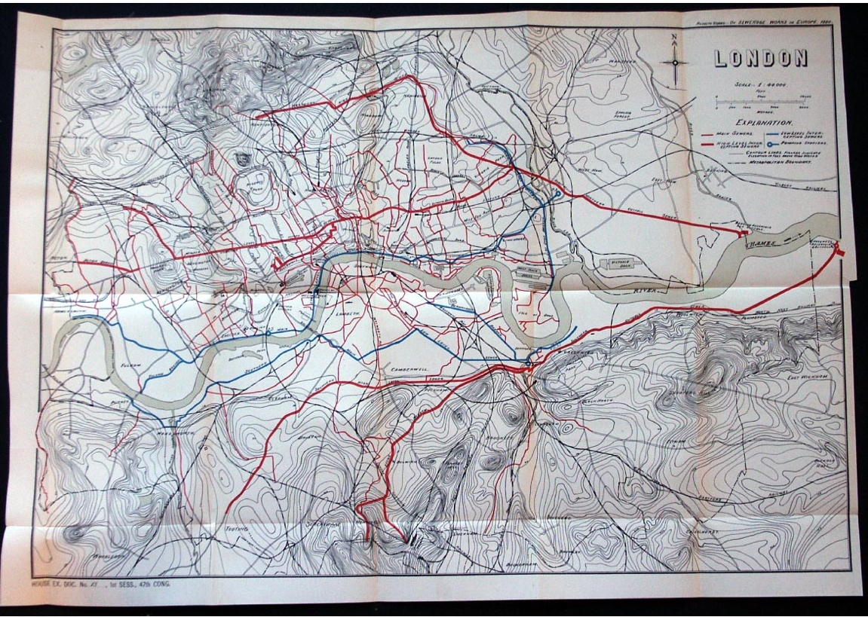

Figure 1: Sewage system of London, 1882[1]

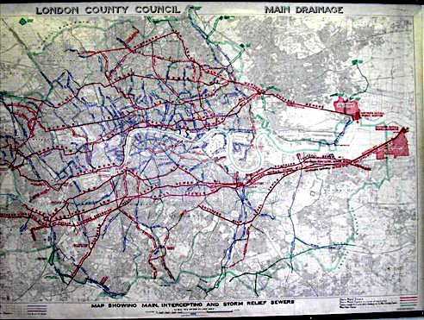

Figure 2: Drainage system of London, 1950s[2]

# Map purpose

# Principally, the target audience is an extended group consisting of citizens, students but also specialized workers. The map will be Web-based and accessible to a broad public and it will provide a faster and easier way to graphically visualize the network and its properties. The final product will be published on the Web and it could potentially be linked to the City Council Web Site[3].

# Data source

# The data have been downloaded from a NZ geoportal (<https://koordinates.com/>) from which the Shapefiles of the the supply, drainage and treatment networks can be freely downloaded. All the data are published using two licenses: the *CC BY-SA 3.0 (Attribution-ShareAlike 3.0 Unported)[4]* for basemap data such as DSM and municipality boundaries and the *CC BY-NC 3.0 NZ (Attribution-NonCommercial 3.0 New Zealand)[5]* for the data of the networks.

# As basemap we might consider to use a prebuild map from MapBox.

# General design

# The Webpage of the map will consist of:

# The map combined with general navigation activities (zoom, panning, etc.).

# The Menu bar with title, imprint and optionally also a searching function.

# A further bar for the thematic navigation through the different layers.

# The basemap will be composed by:

# Streets (divided in different categories: main streets, secondary streets, dirt roads, paths, etc.)

# Buildings (divided in different categories: private buildings, city hall, museums, monuments, etc.)

# Municipality boundaries

# Water areas

# To visualize the elevation profile of the basemap, the contour lines and the shading could also be considered.

# The thematic part will be divided in three line-vector layers:

# Water supply network

# Water drainage network

# Water treatment network

# These layers will be styled:

# in size according to nominal diameter

# in shape and color according to the type of material, and additionally to gradient.

# Optionally, a temporal navigation bar will be added to provide a further point of view about the development in time of the networks. Further, more specific information about single features of the layer will probably displayed by clicking on the specific feature (the different parts of the water supply, drainage and treatment networks including water treatment centers, manholes or hydrants) e.g. by using a Pop-up window.

# Infrastructure and Technology

# The technologies used are going to be html for the GUI, CSS for the style and Javascript for the interaction. Furthermore, cartographic dedicated libraries are going to be used (Leaflet D3, Openlayers, etc.).

1. **Time schedule**

The project will have the following deadlines:

* 11.04.2016: Concept refinements
* 14.04.2016: Data acquisition and processing.
* 22.04.2016: First decision of basemap design.
* 12.05.2016: GUI implementation.
* 19.05.2016: Final decision of basemap design.
* 14.06.2016: Layer styling and interaction.
* 21.06.2016: Finalizing map.

1. Source: http://freepages.genealogy.rootsweb.ancestry.com/~genmaps/genfiles/COU_files/ENG/LON/hering_lon-sewer_1882.html
2. Source: http://www.hhgs.org.uk/monthly_meetings/previous_meetings/thames_tideway/thames_tideway.html
3. City Council Web Site: http://wellington.govt.nz
4. # Source: http://creativecommons.org/licenses/by-sa/3.0/

  
5. # Source: http://creativecommons.org/licenses/by-nc/3.0/nz/

  